Marketing Guide

## Background:

Industry : health care – increase phsical activity & form good habits

Problem : Type 2 disabetes, it can only be cured by exercise and good diet

-major causes

1. actvity & food

2.environment

3.genetics

4.conditions & medication

5.stress & sleep

Solution : focus on actvity & food, environment

-Motivation is key feature

-provide reason to become healthy and being active

-understand own body condition

-step by step process to lose weight

How : with mobile application

-below are steps for using app

1.test the body condition

2.base on the body condition, app gives appropriate mission to become physically active

3.when patients accompolish the mission, they get points

4.some patients can get stars when they constantly finishing mission well

5.with points and star, patient can get discount

## Market background:

Target Audience : unhealth routine, bad habits, pain from type 2 diabetes

-possible audience :170m(included overweight) US people

-age from 18 ~ 45

-low income family

-unactive or indoor people

Target market : fitness appstore_TAM 22.4b

-IOS app store_fitness category

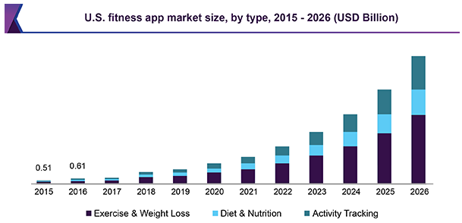

Competitors : health care application

-top 5 applications take 90% of market share

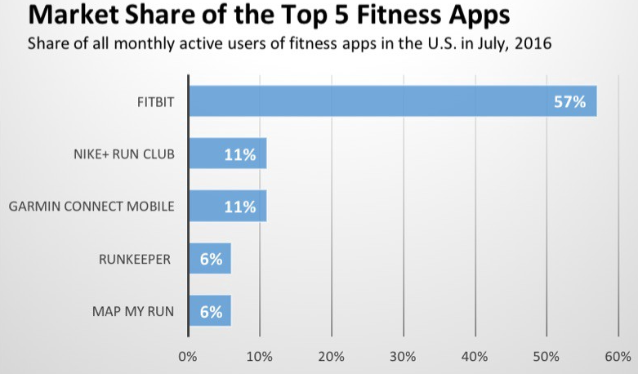

## Product Background and Positioning:

Product positioning :

-for age 18 ~ 45 obesity people, our KP’s health care app delivers great support to patient. Because we build our app focusing on motivating to become physically active and change the environment. This approach has not been found from other apps.

Value proposition : main value of this app is motivation

-companion

-with app, user can have sense of bond

-remote support

-any questions are available

-clear & individualized process

-personalized activity given

-respect user’s goal

Features : Related to motivation

-reward system : external motivation tool to help patient losing weight

-user can collect points by accomplishing mission. reward can be selected with points

-health test : deeper understand of own body

-help understand body in number and graphic

-internal motivation by facing seriousness of body condition

-24/7 Q&A : sense of bond and relation formed

-user can ask any questions

-help setting realistic goal

Overall process of the app

